LYNDEN SCHOOL DISTRICT #504

Medication Administration
Training Manual
for
Non-Licensed
School Personnel



Kathy Vanderveen, RN 318-6044
Karen Matheis, LPN 815-4056
Sharon Reese, LPN 296-4774

Table of Contents

FORWARD 4
ACKNOWLEDGEMENT 4
Course Overview 5

Module I: Legal Issues, Policies and Procedures 7

Introduction 8
Laws Related to Medication Administration 8
Role of Unlicensed Personnel in Medication Administration 11
Confidentiality and Privacy 11
Other Legal Considerations in Medication Administration 12

Module II: Classification of Medications, Medications Preparations, Administration & Documentation 17
Classification of Medications 18
Medication Resources 18
Understanding Effects of Medications/Adverse Drug Effects 19
Various Forms of Medication Administration 20
Handling Medication 22
Procedure for Administering Medications 24
Medication Errors 24
Refusal of Medications 24
Medication Documentation (Medication Log/Medication Administration Record) 24
Sample Forms 26

Module III: Emergency Medication Administration 30
Epinephrine for Anaphylaxis 31

Module IV: Local School District Policies and Procedures 32
Medication Administration 33
_Lynden School District Policy/Procedures 3416 34

Handouts
Common Medication Abbreviations
Glossary of Medical Terms
Steps for Proper Hand Washing
Six Rights of Medication Administration
Brand and Generic Names for Common Medications
Common Medications
Medication Administration Incident Report Form
Student Self-Medication Authorization
Family Educational Rights and Privacy Act (FERPA)
Appendix
Competency #1 – Oral Medication Administration
Competency #2 – Liquid Medication Administration
Competency #3 – Eye Drops or Ointment
Competency #4 – Ear Drops
Competency #5 – Topical Ointment or Creams
Competency #6 – Metered Dose Inhaler (MDI) and HFA (hydrofluoroalkane) Inhalers
Competency #7 – How to Administer an EpiPen®

Medication Administration Written Competency Test for Non-Licensed School Personnel
Module I: Legal Issues, Policies and Procedures
Module II: Classification of Medications, Medication Preparation, Administration & Documentation
Module III: Emergency Medication Administration
Module IV: Local School District Policies and Procedures

FOREWARD

The Lynden School District (504) recognizes the need for a standardized medication administration training program for unlicensed school personnel that will ensure student safety. Clarification of what may be safely delegated per RCW 28A.210.260 and RCW 28A.210.270, as well as an understanding of procedures related to medication administration by unlicensed personnel, is needed because a licensed nurse may not be physically present in the school building at all times.

A standardized training curriculum for medication administration by unlicensed school personnel was developed by certificated school nurses in collaboration with NorthEast Washington Educational Service District (NEWESD) 101. The curriculum has been reviewed and approved verifying compliance with RCW 28A.210.260 and RCW 28A.210.270. This curriculum is the official training program for all unlicensed school personnel who accept delegation to perform medication administration.

All curriculum revisions shall be made when Washington law indicates revisions are needed.

ACKNOWLEDGEMENT

Reviewers

The authors gratefully acknowledge the useful critique of the draft manuscript of the Medication Administration Training Manual for Non-Licensed School Staff, by the following reviewers:

Amy Degon, RN Katie Johnson, MN, RN-BC, NCSN
Rosalia School District Office of Superintendent of Public Instruction

Janice Doyle, MSN, RN, NCSN, FNASN Julie Schultz, BSN, RN,
Bethel School District Northeast Washington Educational Service District

Dawn Epler, BSN, RN, Wendy Supanchick, BSN, RN
Deer Park School District Riverside School District

Alma McNamee, MS, BSN, RN
Northeast Washington Educational Service District

Portions of this manual were used with permission of the
Kentucky Department of Education
Frankfort, Kentucky 40601

Course Overview

Course Objectives

Upon completion of this course, unlicensed school personnel will be able to:

- Understand how medication administration may be safely delegated

- Identify the responsibilities of the school nurse and unlicensed school personnel in medication administration

- Understand local school board policies for medication administration

- Recognize and apply the six (6) rights of medication administration

- Identify proper storage of prescription and over-the-counter medication

- Understand appropriate and correct documentation of medication administration

- Understand proper action and documentation necessary for refusal and omission of scheduled medications

- Understand prevention of medication errors and incident reporting

- Recognize when it is appropriate to contact additional resources (i.e., nurses, physicians, poison control and emergency medical services)

Course Goals

This course is intended for non-licensed personnel who have accepted the delegation to provide medication administration to students in a school setting. According to 504 Policy/Procedure 3416, designated staff members will participate in an in-service training session prior to the opening of school each year. As per 504 Policy 3416, the delegation is only valid for the current school year.
It is understood the employing school will reserve the right to recommend individuals for this training. Upon successful completion of this course the non-licensed school employee will demonstrate competency, as determined by the delegating registered nurse (RN), in:

- Administration of student medication

- Verification of student instruction on self-administration of medications

- Administration of emergency medications for students with allergic anaphylactic reactions

Course Description

This course is designed to include four modules:

Module I: Legal Issues, Policies and Procedures
Module II: Classification of Medications, Medication Preparation, Administration,
and Documentation

Module III: Emergency Medication Administration
Module IV: Local School Board Policies and Procedures

Medication Administration Open Book Exam and Demonstration of Skill Competency
A study guide has also been developed to assist with this training material. Personnel will be expected to score a 100% on the skill competency evaluation and 85% on an open book final exam which will include demonstration of:
- Reviewing student medication history on Medication Administration Record/Medication log for documentation of allergies and other co-existing medical conditions
- Using proper hygiene/universal precautions in medication preparation
3. Accurately identify student medication information by comparing medication label to the transcribed Medication Administration Record/Log

4. Application of:
- Eye drops/ointment
- Ear drops
- Topical ointments/creams
5. Administration of oral medications

6. Correct use of oral inhalers

7. Use of emergency medication (EpiPens®)

8. An understanding of policies and procedures

A score of 85% must be achieved on the open book exam and a score of 100% on the skill competency evaluation to pass the course. School personnel may repeat either the failed exam or skill competency evaluation one time. If school personnel fail the final open book exam or the skill competency evaluation twice, they must repeat the training course.

Personnel who are trained and delegated to perform medication administration only of EpiPen®/inhalers, will be expected to score 100% on the final skill competency evaluation for Competency #7-How to Administer an EpiPen® and 85% on the open book final exam for Module #3- Emergency Medication Administration.

Module I

Legal Issues

Policies and Procedures



Module I: Legal Issues, Policies and Procedures

Introduction
Many children with chronic health conditions or illnesses attend Washington’s public schools and may require medication that would affect attendance or program participation. While many schools may have a licensed nurse available, there are also schools where students do not have access to a licensed nurse to receive their medication. Due to the increasing number of students who require medication during the school day, whether in the classroom or on a field trip, school nurses sometimes need to delegate the administration of student medications.

There is much more to administering medications than just handing a student a pill and keeping the medicine bottle in a drawer. This curriculum was developed to give school personnel more information about:

- Current Washington laws
- School district policies and procedures regarding delegation of medication administration
- Process of administering medication
- Correct and appropriate documentation
- When to seek additional assistance from resources such as a nurse, poison control or emergency medical services

The curriculum was developed collaboratively with the Lynden nursing staff, NEWESD 101 and OSPI.

Laws Related To Medication Administration
The number of students with complex health issues attending school is increasing. Of the students who may require medication during the school day, some require prescribed medications at a scheduled time daily. Others may require over-the-counter medication episodically, such as to treat a headache. Some students may have a chronic health condition that requires an emergency medication or treatment to reduce the threat of a potential life-threatening event. (RCW 28A.210.320)

The potential for unsafe administration of medication in all these scenarios poses a possible liability for schools. An understanding of state laws and school district policies and procedures is necessary to reduce the potential liability issues of medication administration in the school setting. School personnel who accept the delegation of medication administration, and comply with the training, delegation, and supervision provided by the school nurse, successfully complete this course, including demonstrated competency, are protected from liability under Washington state law (RCW 28A.210.270).

Only licensed physicians and surgeons, dentists, osteopathic physicians and surgeons, naturopathic physicians, podiatric physicians and surgeons, physician assistants, osteopathic physician assistants, and advanced registered nurse practitioners (ARNPs) are licensed to “prescribe” medication (RCW 18.71 and RCW 18.79). Nurses are licensed to “administer” medications. Lynden Public SchoolsPolicy 3416, allows only registered nurses, in the school setting, to delegate the task to administer medications to persons who have completed a course such as this, and have demonstrated competency (RCW 28A.210.260). School personnel may be trained to administer the emergency medications- inhalers and Epipens®. (RCW 28A.210.260, RCW 18.79.240(1)(b), and Lynden Public Schools Policy 3416, Guidelines for Care of Students with Anaphylaxis)
In Washington, nurses working in schools may be either an ARNP, registered nurse (RN) or a licensed practical nurse (LPN). There is a difference in the educational preparation and scope of practice between the ARNP, RN and LPN. The scope of practice for the ARNP, RN, and LPN are defined in WAC 246-840 and described below.

1. Advanced Registered Nurse Practitioner

It is within the scope of the ARNP to provide primary healthcare services to students in accordance with WAC 246-840-300, scope and standards of practice of ARNPs. The ARNP may also perform acts within the scope of registered nursing practice.

2. Registered Nurse Practice

According to the National Association of School Nurses (NASN), The Role of the School Nurse (1999) and WAC 246-840-705, it is within the scope of registered nursing practice for a registered nurse, qualified by education, experience, and current clinical competence to provide school health services/acts including but not limited to the following:

  - Utilize substantial, specialized nursing knowledge, judgment and skill in providing primary healthcare to students including initial assessment, management of illness and/or referral to other health professionals, monitoring of chronic diseases, health supervision, counseling, and promotion of healthy life-styles, disease prevention, and the coordination of services when specialized care is required.
  - Serve as a health advocate of students, and a consultant to educational staff
  - Serve in family resource and youth services centers
  - Provide health teaching with a focus on disease prevention, health promotion and health restoration
  - Monitor the quality of the healthcare services provided for students
  - Provide direct clinical services for students with special needs and/or teach and verify competency, supervise and delegate [as defined in RCW 18.79.040(1)(0) and RCW 18.79.260(2) the performance of select acts to unlicensed school personnel in accordance with the administrative regulation governing delegation of nursing tasks to unlicensed persons
  - Participate in the development of policies and procedures to guide nursing practice in school settings (RCW 28A.210.260), and to address expanding school health services to students, families and communities
  - Delegate select health services to a school employee in accordance with
RCW 18.79.040(1)(0) and RCW 18.79.260(2).

3. Licensed Practical Nurse Practice

WAC 246-840-705 defines licensed practical nursing practice (LPN). By definition, licensed practical nurses practice under the direction of licensed physicians and surgeons, dentists, osteopathic physicians and surgeons, naturopathic physicians, podiatric physicians and surgeons, physician assistants, osteopathic physician assistants, and ARNPs. LPNs are not licensed for independent nursing practice. The board recognizes the participation of the LPN in school nursing practice when the LPN is qualified by education, experience and current clinical competency and practices under the direction and supervision of a designated RN. The LPN performs acts within the scope of licensed practical nursing practice as defined in WAC 246-840-705.

LPNs may administer medications and treatments as prescribed by licensed physicians and surgeons, dentists, osteopathic physicians and surgeons, naturopathic physicians, podiatric physicians and surgeons, physician assistants, osteopathic physician assistants, and ARNPs. Supervision of the LPN does not require the supervisor to be physically present in the same building. However, the LPN may not practice without oversight of the nursing care provided to students by at least a RN.

While there are similarities in the RN practice and the LPN practice, the degree of educational preparation and the responsibilities of each are different. Both the RN and LPN must hold a current license from the Nursing Care Quality Assurance Commission (NCQAC) and their licenses must be renewed annually. For licensure renewal, each nurse is required to complete approved continuing education. These and other laws are in place to govern the practice of nurses in the state of Washington and to ensure the health and safety of those served.

The NCQAC has the legal authority (RCW 18.79 and RCW 18.130) to regulate nursing practice in order to safeguard the health and safety of citizens of Washington. Delegation is defined by the American Nurses’ Association as “the transfer of responsibility for the performance of an activity from one individual to another, while maintaining the accountability for the outcome.” School health services (i.e., the administration of medications) may be delegated to unlicensed school personnel according to related sections of RCW 28A.210.260 and RCW 28A.210.270, which describes who may delegate health service(s) (ARNP, RN), the training and documentation of the training. The delegation and training is only valid for the current school year (Lynden Public School Policy 3416).

For school nurses, NCQAC (WAC 246-840-700) Standards of Nursing Conduct or Practice discusses delegation of nursing tasks to non-licensed personnel (WAC 246-840-010(10), and provides direction on how tasks may be delegated to a non-licensed individual by a licensed registered nurse. The delegating school nurse will also be responsible for ongoing training and competency evaluations of the non-licensed personnel to safeguard the health and welfare of the students in their care.

Supervision is defined as “the provision of guidance by a qualified nurse for the accomplishment of a nursing task with periodic observation and evaluation of the performance of the task” (WAC 246-840-010(10)). The evaluation should include validation that the nursing task has been performed according to established standards of practice. Even when unlicensed school personnel perform the task, the nurse who delegates the task, will retain the responsibility for the outcome. Supervision of unlicensed school personnel does not require the delegating nurse to be present in the same building. However, the delegating school nurse should be available by phone for consultation.

Role of Unlicensed Personnel in Medication Administration

“The Staff Model for the Delivery of School Health Services” established the definition of “health services” and the provisions for who may provide health services in schools. Unlicensed school personnel may be delegated selected health services according to RCW 28A.210.260.

When accepting the delegation to perform medication administration in the school setting, the unlicensed school personnel performs this function under the supervision of the delegating licensed professional nurse. Unlicensed school personnel should only accept delegation that he/she knows is within his/her skill set or knowledge and should always contact the supervising school nurse if unclear about administering a medication. Unlicensed personnel have the responsibility to follow school district policies and procedures and report to the nurse if they have any reason to believe they have made a medication error. This should be reported as soon as possible.

Confidentiality and Privacy

Confidentiality is a very important legal concept in the school setting. The Family Educational Rights and Privacy Act (FERPA) is the federal law that protects the privacy interests of students and their educational records. FERPA applies to any educational agency that receives funds from the United States Department of Education (USDOE). Health records maintained by school employees for pre-kindergarten through grade 12 students are protected by FERPA.

Information regarding student health information should be shared with school personnel only on a “need to know” basis (RCW 70.02.030 thru RCW 70.02.050). Health records contain sensitive information and may not be disclosed without parental/guardian permission. Certain student health information may be necessary to share with school personnel who may be assisting with medication administration. However, this information is confidential and should not be shared with other students or school employees (RCW 70.03.030-050).

Privacy is a separate legal concept. If a student tells school personnel how they feel about having a chronic health condition, this information should be shared with the school nurse but not disclosed to those who do not have a “need to know”.

Other Legal Considerations in Medication Administration

All school districts should have written policies and procedures on medication administration. The purpose of these policies and procedures are to give guidance to the local school district employees and students. Each school district employee administering medications should be familiar with their district’s policies and procedures on medication administration.

- Administration of Medication

- Prescribed medication – whether medication requires a prescription or is over-the-counter (OTC):

Prescribed medication must be sent to the school in the original labeled container and the label shall include:

- Name of the student
- Expiration date of the medication
- Name of the medication, dosage and strength of medication
- Route of administration
- Frequency of medication
- Name and address of the pharmacy*
- Name of the prescribing health care provider*
- Date the prescription was dispensed*

*These would be included only on prescription medications from the pharmacy.

An authorization form completed by the parent/legal guardian and the student’s health care provider (HCP) must be kept in the medication notebook and is only valid for the current school year.

- Student self-medication

Student self-medication is allowed in certain situations, with a written health care provider’s authorization, that allows a student to responsibly carry self-administered medication (e.g., Epipen® or asthma inhaler). An authorization form must be completed by the parent/guardian and health care provider and on file in the school. This authorization must be renewed each school year and be approved by the school nurse. Documentation from the prescribing HCP shall include:

- The student has demonstrated proper technique and is capable of administering the prescribed medication
- The name and purpose of the medication
- The prescribed dosage of the medication
d. The times at which or circumstances under which the medication may be given
e. The period of time for which the medication is prescribed
f. The side effects and further instructions if order is for more than fifteen days.

3. Medication safety

The first dose of any new medication should be given at home and not at school. Except for “self-carry” medications, all medication should be brought to the school by a parent or guardian and picked up.

According to school district policy and procedures, prescribed medication should be counted and the number of pills received should be noted on the Medication Administration Record and signed by two adults, preferably one being the parent/guardian.

Medication shall only be administered according to the health care provider’s instructions on the Medication Authorization form and this should match the information on the prescription label. (Staff may apply clear tape over the label to maintain legibility of label.) Discrepancies that exist between the information on the Parent/Guardian Authorization Form and the prescription label will require one of the following:

a. New authorization form completed by the parent/guardian and HCP
b. New prescription bottle or label issued by the pharmacy

Medications shall not be given beyond the date specified on the authorization form, or beyond the expiration date on the label.

4. Changes in medication

The authorization to administer medication is only valid for the current school year or until treatment changes. A new Authorization for Medication Administration form must be obtained whenever there is a change to the medication, dosage, time and/or frequency and a new prescription bottle (or medication label if applicable) from the pharmacy indicating the prescription change.

Nurses may only accept medication orders as prescribed by HCPs with prescriptive authority. Nurses may not accept requests from parents to change a prescribed medication dose without first contacting the prescribing HCP.

B. Storage and Disposal of Medications

Except for emergency medications (EpiPen®/asthma inhalers and antihistamines used for severe allergies) specified in an emergency care plan, all medications should be kept in an appropriately labeled, secure, locked container or cabinet accessible only to the responsible authorized school personnel. Medications requiring refrigeration shall be kept in a separate refrigerator in a supervised area or locked container that can be stored with food in a supervised area. Temperature of that refrigerator will be checked on a regular basis and the temperatures documented on a log. Temperatures should be maintained between 33 and 45 degrees Fahrenheit.

For students receiving medication throughout the school year, it is recommended that no more than a month’s supply of medication be stored on school property.

When a medication is no longer needed, the school should notify the parent/guardian and request that it be picked up by the parent/guardian.

For disposal of unused medication or expired medication that has not been picked up by parent/guardian:

- For pills: Pour into wet coffee grounds. After pills have dissolved, they may be thrown into garbage can.
- For liquids: Pour into coffee grounds. This may be placed in plastic bag and then thrown into garbage can.
- Disposal of medication must be documented on the student’s medication record to verify it was destroyed, sign, date and have a witness also sign and date.
- Items such as inhaler canisters may be placed in a sharps container or disposed of according to the school district’s Bloodborne Pathogen OSHA plan.
- Expired EpiPens® are used by school nurses for unlicensed staff training.

C. Field Trips and Medication Administration

If a student is attending a field trip away from school during his/her scheduled medication time, school personnel with current training on medication administration may be designated to administer the medication while on the field trip.

Notification and preparation for administering medications during a field trip should begin well in advance of the day of the field trip (at least two (2) weeks). Student medication may not be repackaged for field trips by school personnel. The school should request the parent send a separate bottle to be sent on the field trips. The medication bottle should also have a pharmacy prescription label attached. Consult local school district policies and procedures for field trip medication administration. (Module IV)

D. Refusal of School Personnel to Administer Medications
When school personnel are unable to grant the request from a parent/legal guardian/HCP to administer medication to a student, the delegating school nurse should be notified as soon as possible. Some of the circumstances may include:

- Medication was sent to school out of the original container
- Medication is prescribed twice daily and can be administered before school and after school hours
- Medication is prescribed three times daily and can be given before school, after school and before bedtime
- No written authorization is on file

Other unusual circumstances that are not listed above will require consultation with the supervising school nurse.

A student may refuse medications. As best practice and according to the student’s developmental level, the student should understand the symptoms for which the medications are prescribed and also know any common side effects. The student should be able to verbalize their understanding that these medications are considered a part of treatment and that the parent and/or prescriber will be notified should he/she refuse the medication.

Refusing medications is not considered a medication error and should be documented on the Medication Administration Record as “refused medication.” This shows that the individual has been offered the medication as ordered by the HCP. When a student refuses medications, the school nurse and parent should be notified as soon as possible.

E. Medication Errors

Preventing and Reporting Medication Errors

A medication error occurs when one of the “six rights of medication administration” has been violated. Examples are:
- Administering the wrong medication
- Administering the wrong dose of medication
- Administering medication at the wrong time
- Administering the medication in the wrong way (e.g., ear drops administered to eye)
- Administering medication to wrong student
- Failing to document that medication was given or inaccurate documentation of medication given

Medication errors may result in adverse reactions to the student. These reactions could range from a rash to a life-threatening situation. Therefore, always check the medication label when:

- Removing the medication from storage
- Removing the medication from its container
- Returning the medication to storage

Knowing the following before administering medications will help prevent medication errors:

1. Name of medication (the generic and real or “trade” name)
2. Purpose
3. Potential side effects
4. Special instructions (if appropriate)
5. Health care provider and emergency contact names and phone numbers

When a medication administration error occurs, follow these guidelines:

1. Keep the student in the health room or office (where they can be observed)
2. If the student has already returned to class, have an adult accompany the student back to the health room or office, for observation
3. Observe the student’s status and document what you see
4. Identify the incorrect dose or type of medication taken by the student
5. Notify the principal and supervising school nurse immediately if medication was given by non-licensed personnel (The supervising nurse will contact the parents of the student and/or health care provider.)
6. If contacting the Poison Control Center for instructions:

a. Give the name and dose of the medication taken in error
b. Give the student’s age and approximate weight
c. Give the name and dose of any other medication the student receives

7. Follow instructions from the Poison Control Center. If unable to follow their instructions, explain the problem to the Poison Control Center to determine if the student should be transported for emergency care.

8. Complete a Medication Administration Incident Report form. Carefully record all circumstances and actions taken, including instructions from the Poison Control Center or the student’s health care provider, and the student’s status. All reports are to be filed and kept according to district policy.

Errors made in recording medications on the Medication Administration Record should be marked “error,” initialed and dated. Whiteout may not be used nor documentation “blacked” out.

Module II

Classification of Medications, Medications Preparation, Administration, and Documentation

Module II: Classification of Medications, Medications Preparation, Administration, and Documentation

Classification of Medications

Prescription Medications

Prescribed medications are those medications that a HCP has ordered for treatment of a student’s particular diagnosis or symptoms. These medications may include controlled/scheduled or non-controlled/scheduled. Prescribed medications may be ordered on an as needed basis (PRN) or on a routine scheduled basis.

A. Controlled/scheduled medications
“Controlled/scheduled medications” are medications that are potentially addictive and that are regulated under the Controlled/Scheduled Substance Act of 1970. Controlled/scheduled medications cannot be obtained without a written prescription from a licensed practitioner (e.g. Ritalin® or Tylenol® with Codeine).

It is very important that controlled/scheduled medications be handled according to school district policies and procedures:
- Kept locked in appropriately constructed medication cabinet
- Signed out each time a dose is administered
- Disposed of according to medication storage and disposal guidelines in Module II

B. Non-controlled/scheduled medications
All prescription, non-controlled/scheduled medications (e.g.,Tegretol® or Dilantin®) require an order from a HCP. All non-controlled/scheduled medications are kept locked according to school district policies and procedures. School district policies will address student safety in relation to secure storage of medication.

C. Over-the-Counter (OTC) Medications

OTC medications are administered to students according to school district policy. OTC medications require a completed authorization form by the parent/legal guardian and the student’s HCP. Examples of these medications would be ibuprofen (Motrin®), acetaminophen (Tylenol®), cough medication (Robitussin®), antibiotic ointment (Neosporin® or Bactracin®), antacids (Tums® or Rolaids®), etc. Documentation of OTCs on the student’s Medication Administration Record is required.

Medication Resources

The chart “Common Medications” (Handouts section) lists commonly used medications. These medications may be controlled or non-controlled. The chart is not an all inclusive list. It is very important that a person administering medications compares the medication label with the medication record including the student’s name, time of administration, how the medication is to be given and the dosage for administration. All OTC medications must be given in accordance with school district policies.

It is recommended that school employees administering medication have access to an updated drug book for review of any newly prescribed medications and/or over the counter medication when questions arise.

Student health information is important for student safety in medication administration and management. This information includes, but is not limited to: student name, date of birth, sex, and any allergies.

Understanding Effects of Medications/Adverse Drug Effects

It is very important to be familiar with any medication that is being administered. An adverse effect is an unwanted, unexpected and/or dangerous reaction to a drug. Pharmacies are required to provide a “medication” education sheet with each drug dispensed. The sheet contains the most common adverse effects of that medication.

Another way to learn the adverse effects of medications is to review the medication in a current drug handbook. These books are updated on an annual basis and contain the most current Information on newly developed drugs, to include recommended dosage; what diagnosis or symptom the drug treats; how the drug is absorbed; and most importantly the potential side effects/adverse effects of the drug. Medication information is also available online at the:

National Institute of Health’s website Medline Plus: http://nlm.nih.gov/medlineplus/druginformation.html

Observing the student after a medication has been administered is crucial in identifying any adverse reactions to that medication. If a student vomits after taking a medication, report to the supervising school nurse the student’s name and age; medication name and dose; and time interval between the medication administration and when vomiting occurred. Severe adverse reactions should be treated as emergencies and unlicensed school personnel should be familiar with school district policies and procedures regarding how emergencies are to be handled.

An allergic reaction is an immune response to a foreign substance resulting in inflammation and/or organ dysfunction. In the case of medications, the drug itself may be the substance that causes the effect. Allergic reactions may have many symptoms that could appear immediately or not for several days or weeks. Examples of an allergic reaction may be: redness, rash, hives, shortness of breath, itching, swelling, yellowing of the skin, fever, and/or nausea/vomiting.

Anaphylaxis is the most dangerous type of an allergic reaction. Anaphylaxis is a life-threatening event, where the blood pressure drops, respiratory distress occurs (i.e., shortness of breath), and the student may become unresponsive. Emergency procedures should be implemented if anaphylaxis is suspected.

Various Forms of Medication Administration
Medications may be administered in many different ways. Procedures for administering different forms of medication are located in the Handout section of this manual.

A. Oral (by mouth)
Oral medications include solid forms such as tablets or capsules and liquid forms such as syrups/elixirs and suspensions. Oral medication should not be crushed without an HCP’s order.

Tablets (pills) come in many forms: regular, chewable, sublingual and scored. Regular tablets are simply taken with liquid. Chewable tablets should be chewed before they are swallowed. Tablets that are not clearly designated as chewable should be swallowed whole. Scored tablets are designed so that they can be cut up into smaller doses with a special cutting tool. Tablets are delivered in either enteric coated or uncoated form. Certain medications can cause irritation to the stomach. These tablets are “coated” so that they cannot dissolve in the stomach, protecting the stomach from irritation. The “coating” actually dissolves in the small intestine instead of the stomach. These tablets should not be split or crushed.

Oral disintegrating tablets dissolve in the mouth (do not chew). Sublingual medications are placed under the tongue to be dissolved and absorbed. Buccal medications are placed inside the cheek and along the gum line to be dissolved and absorbed.

Capsules are coated so they dissolve over a period of time in the stomach or the intestines - but not in the mouth. Most often, the prescription calls for capsules to be swallowed whole, just like tablets. Gel coated capsules are not to be broken.

There are also capsules designed to be broken apart and sprinkled onto soft food, like applesauce. These are called a “sprinkle” and are most often given to students who have asthma or seizures. If a capsule should be “sprinkled,” the directions on the prescription will specifically say to do so.

Capsules may be coated with substances that permit delayed release in the small intestine in small amounts over a prolonged period of time. Do not break or crush any medications considered slow release, sustained release, long-acting, extended or controlled release (usually identified with SR, LA,
EX or CR).

Syrups and elixirs are clear liquids. Suspensions are liquids that are not clear. Suspensions contain medication that doesn’t dissolve completely in the liquid and usually need to be refrigerated. Because suspensions can separate, they always need to be shaken at least 15 seconds before being measured and given to the student.

All oral medications should be given with water or other liquid that allows for easy swallowing. After the student has received the medication, it is very important to make sure he/she has swallowed the medication. Ask the student to open his/her mouth and raise their tongue. Inspect cheeks, under tongue, roof of mouth, and teeth for hidden medication. Check orthodontic braces as well. This practice will ensure students are not hoarding medications (cheeking).

B. Topical
Topical medications include eye drops or ointments, ear drops or ointments, and creams and ointments that are applied to the skin. NOTE: Gloves should be worn when administering any of the following medications. Hands should be washed before and after use of gloves. Be sure to wash your hands after removing gloves.

Ointments (salves) are a semisolid preparation, usually containing a medical substance, used for external application on the skin.
Creams are a fluid mixture of a thick consistency, usually applied to the skin or body surface.

Drops are a liquid form of medication given through a dropper when a very small dose of medication is required. Drops are usually prescribed for the eyes (ophthalmic) or ears (otic).

C. Inhalers and Nebulizers
Inhaled medications may be delivered in a fine mist by spray bottle/inhaler, an oral inhaler or nebulizer machine. Most inhalers are hand-held portable devices that deliver medication at a metered (pre-measured) dose.

A nasal spray/inhaler is medication delivered as a spray directly into the external nares (nostrils) and may be prescribed for allergies. At this time in Washington state schools, nasal medications are not delegable tasks and may not be administered by non-licensed school personnel. Oral inhalers deliver medication directly to the lungs through the mouth by squeezing the canister or by direct inhalation. The nebulizer produces a fine spray mist by rapidly passing air through a liquid that is inhaled through the mouth. Nebulizer medication use may be prescribed for treatment of asthma. Pre-mixed nebulizer medication is already prepared to be used with a nebulizer. Consult the equipment product information on how to use the nebulizer. Individualized training is required to ensure understanding of medication and use of equipment. Common inhaler problems include:
- Not taking the medication as prescribed
- Incorrect activation which may occur by not following the recommended sequencing of inhaling and squeezing the canister
- Forgetting to shake the canister - if the canister is not shaken multiple times, the correct amount of medication may not be delivered-also, prime as indicated per manufacturer instructions
- Not waiting long enough between puffs
- Failure to clean the valve - if debris is present, this will cause delivery failure of the correct amount of medication
- Failure to observe whether the inhaler is actually releasing a spray; if not, call the delegating school nurse

A student’s need for bronchodilators (rescue inhalers) more than every 4 hours can signal respiratory problems. Call the supervising school nurse if this occurs.

Until recently, all MDIs contained a chemical harmful to the earth’s ozone (CFC). The government is requiring that all MDIs be transitioned to HFA (hydrofluoroalkane) inhalers which are more environmentally friendly. The new HFA propelled inhalers are different than what most students may be accustomed, and education may be required. Some differences include:

- Since there are only branded products available, prescriptions and student instructions should be appropriate to each product.
- The propelled spray (plume) with HFA propelled inhalers are softer than CFC propellants and students need to be reassured that they will be receiving the correct dose of active ingredient.
- HFA MDIs have different cleaning requirements. HFA MDIs need to be cleaned more frequently than CFC MDIs. The HFA medication tends to clog the exit port of the plastic actuator more quickly than CFCs. This prevents medication from reaching student’s airways, which may explain why students sometime report HFA inhalers aren’t working.

- HFA MDIs have different priming requirements. Priming (spraying multiple doses into the air) loads the correct dose of medication inside the inhaler. Each HFA inhaler has different priming instructions-how many sprays are needed and exactly when the medication requires priming-which can be different from CFC priming.

ALWAYS CONSULT THE STUDENT’S ASTHMA ACTION PLAN/PRESCRIPTION FOR INSTRUCTIONS ON HOW TO ADMINISTER THE INHALER.

D. Emergency Medications

Epipen® is an emergency injectable medication (epinephrine) prescribed for treating severe allergic reactions causing life-threatening respiratory distress, or a condition referred to as anaphylaxis.

Anaphylaxis is a life threatening allergic reaction that may be fatal within minutes and requires immediate action. Anaphylaxis may be a reaction to: food (particularly peanuts, tree nuts, fish, wheat or eggs), stinging insects, latex, exercise or medication. See Module III for more information on this medication.

Handling Medication

A. Hand Washing
Before administering any medication to a student, always wash your hands. If the student will touch the medication, he or she should also wash their hands. Good hand washing techniques include washing the hands with soap and water. Alcohol –based hand sanitizers are an alternative to washing only when soap and water is not available. However, if the hands are visibly soiled, wash hands with soap and water. (See hand washing procedure in Handout section.)

B. How to Avoid Touching the Medication
Pour pills, tablets, or capsules into the bottle cap first, then pour them into the disposable medicine cup. (This technique allows for more control in pouring and avoids having to remove extra amounts.) A clean paper towel or catsup-sized paper cup may also be used if the medicine is only one capsule or tablet. Have the student pick up the medication themselves and put it in their mouth.

Some children do not have the developmental skills to put tablets or capsules into their mouth. If you must put the medication directly into the child’s mouth, use disposable gloves. The gloves are considered contaminated after use. Pills may also be given with applesauce/pudding to assist in swallowing if necessary.

C. Cutting or Crushing Tablets
Cutting, crushing or sprinkling of the medication are examples of changing the form of an oral medication. If the form of an oral medication must be changed, (e.g., cutting, crushing or sprinkling) the prescribing health care provider will indicate this in the written prescription and on the pharmacy label.

Scored tablets that must be cut in half to obtain a smaller dose should be cut by the parent/guardian or the student’s dispensing pharmacist. (For example, the medication is packaged in 10 milligram (mg) tablets and the health care provider’s order or prescription indicates the student is to receive 5 milligrams or ½ a tablet.

D. Measuring Liquid Medication
When pouring liquid medications, always place bottle cap upside down on a solid surface to avoid contaminating the inside of the bottle cap. Liquid medications must be measured to ensure accurate dosage. For liquid medications, always use a plastic marked medicine cup, oral syringe or dropper. Pay close attention to the medication order (dosage on the bottle) and find the corresponding markings on the medicine cup or dropper. When using a plastic marked medicine cup, place the cup on a solid, level surface and look at the medicine cup at eye level to ensure the correct amount has been poured. If a student is to receive more than one liquid medication at the same time, each liquid medication must be measured separately.

When pouring the medication out of the container, hold the bottle so the label is in the palm of your hand to prevent spillage and causing the label to be illegible. Some liquid medications are suspensions and require shaking before being administered. This information will be on the label of the medication bottle.

Tips on Using Measuring Tools for Liquid Medicines can be found at the following link:
http://www.cbwchc.org/project/brochures/pdf/Tips%20on%20Using%20Measuring%20Tools%20for%20Liquid%20Medicines%20(English).pdf

Ensuring Accurate Administration of Medication

To safely manage and administer medications to students, the “six rights of medication administration” must be followed. (See Handouts section for the Six Rights )

Note: Only set up and administer one individual's medication at a time. Never document administration of the medication before the student receives it.

Prescription Label Example

04849
Precare Caplet 25 mg
QTY: 30 Expires 8/27/03
Right Student
Right Dose, Right Time, Right Route

Right Drug
Jones, Haley
Pharmacy #04849
4838 Polar Level Rd
Louisville, KY 40213
DEA: BR860780
RPHL JWI (initials of pharmacist)
Date filled: 8/27/02
Take 1 tablet every 8 hours by mouth
MFG: Ther-rx
Dr. James Lind (prescribing physician)

Procedure for Administering Medications

All medication administration procedures must include these basic steps regardless of the type of medication to be administered:

- Student reports to office or call student to the office (or staff go to the student)
- Verify identity of student (using two methods of identification)
- Identify yourself and what you will be doing
- Assemble necessary equipment
- Wash your hands before and after administering medications

Steps to follow when administering each type of medication are located in the Handout section.

Medication Errors

District policies and procedures state what documentation is required if a mistake in medication administration has been made. Any error must be documented on the school district’s “medication error” or incident form and reported as soon as possible to the school nurse, school principal and parents.

Report accidental errors such as:
- Forgetting to give a dose of medication
- Giving medication to the wrong student
- Giving the wrong medication or the wrong dose
- Giving medications at the wrong time
- Giving medication by the wrong route

Accidents do happen and in the interest of the student’s health and safety, report all errors promptly.

Refusal of Medications
Refusing medications is not considered a medication error, and the refusal should be documented on the Medication Administration Record as a “refused” medication. The documentation assures the student has been offered the medication as ordered, and also proves staff followed school district policy in administration/documentation.

As best practice and according to the student’s developmental level, the student should understand why the medication is being administered, and also should be made aware of any common side effects. He/she should also be able to verbalize understanding that these medications are considered a part of treatment and that the parent/guardian will be notified should he/she refuse the scheduled medication. Be sure to notify your school nurse as soon as possible.

Medication Documentation (Medication Log/Medication Administration Record)

Record-keeping is very important when medication is given at school. A medication “log” (medication administration record) must be kept for each student. Each medication given must be recorded on a separate form. The log contains the student’s name, the prescribed medication and dosage, the route the medication is to be given, the time the medication is scheduled to be given and any student allergies.

Compare the information on the medication label with the information on the medication request form. This information must match. Whenever a change in the dose of the same medication is ordered by the

prescribing medical provider, a new medication request form must be created. Contact the school nurse immediately and do not give the medication if the medication label is missing or the label cannot be read.

The medication request form (on the back of the sheet) may be used to also make notes of additional comments of any unusual circumstance related to the student receiving the medication. This medication record becomes a permanent part of the student’s file and provides legal documentation for those who administer medications to students. When a student receives a medication the actual time must be recorded on the medication record. This must also be done when a medication is missed due to an absence or a field trip, or if the student refuses to take the medication. The medication administration record is a legal and permanent document. It is to be saved for 8 years. Use only ink and never use “whiteout.” If a mistake is made in the recording of the time of the medication administration on a medication record form, draw a single line through the time, write “error” and initial/date beside the time.
A sample copy of a student medication request form may be found on the following page.

See local school district medication administration form and follow local school district policies for documentation. (Module IV)

Handouts available:
- Common Medication Abbreviations
- Glossary of Medical Terms
- Steps for Proper Hand Washing
- Six Rights of Medication Administration
- Brand and Generic Names of Common Medications
- Medication Administration Incident Record Form (Sample)
- Student Self-Medication Authorization
- Core Competencies: Oral Medication Administration, Liquid Medication Administration, Eye Drops or Ointment, Ear Drops, Topical Ointment or Creams, Metered Dose Inhalers, How to Administer an EpiPen®

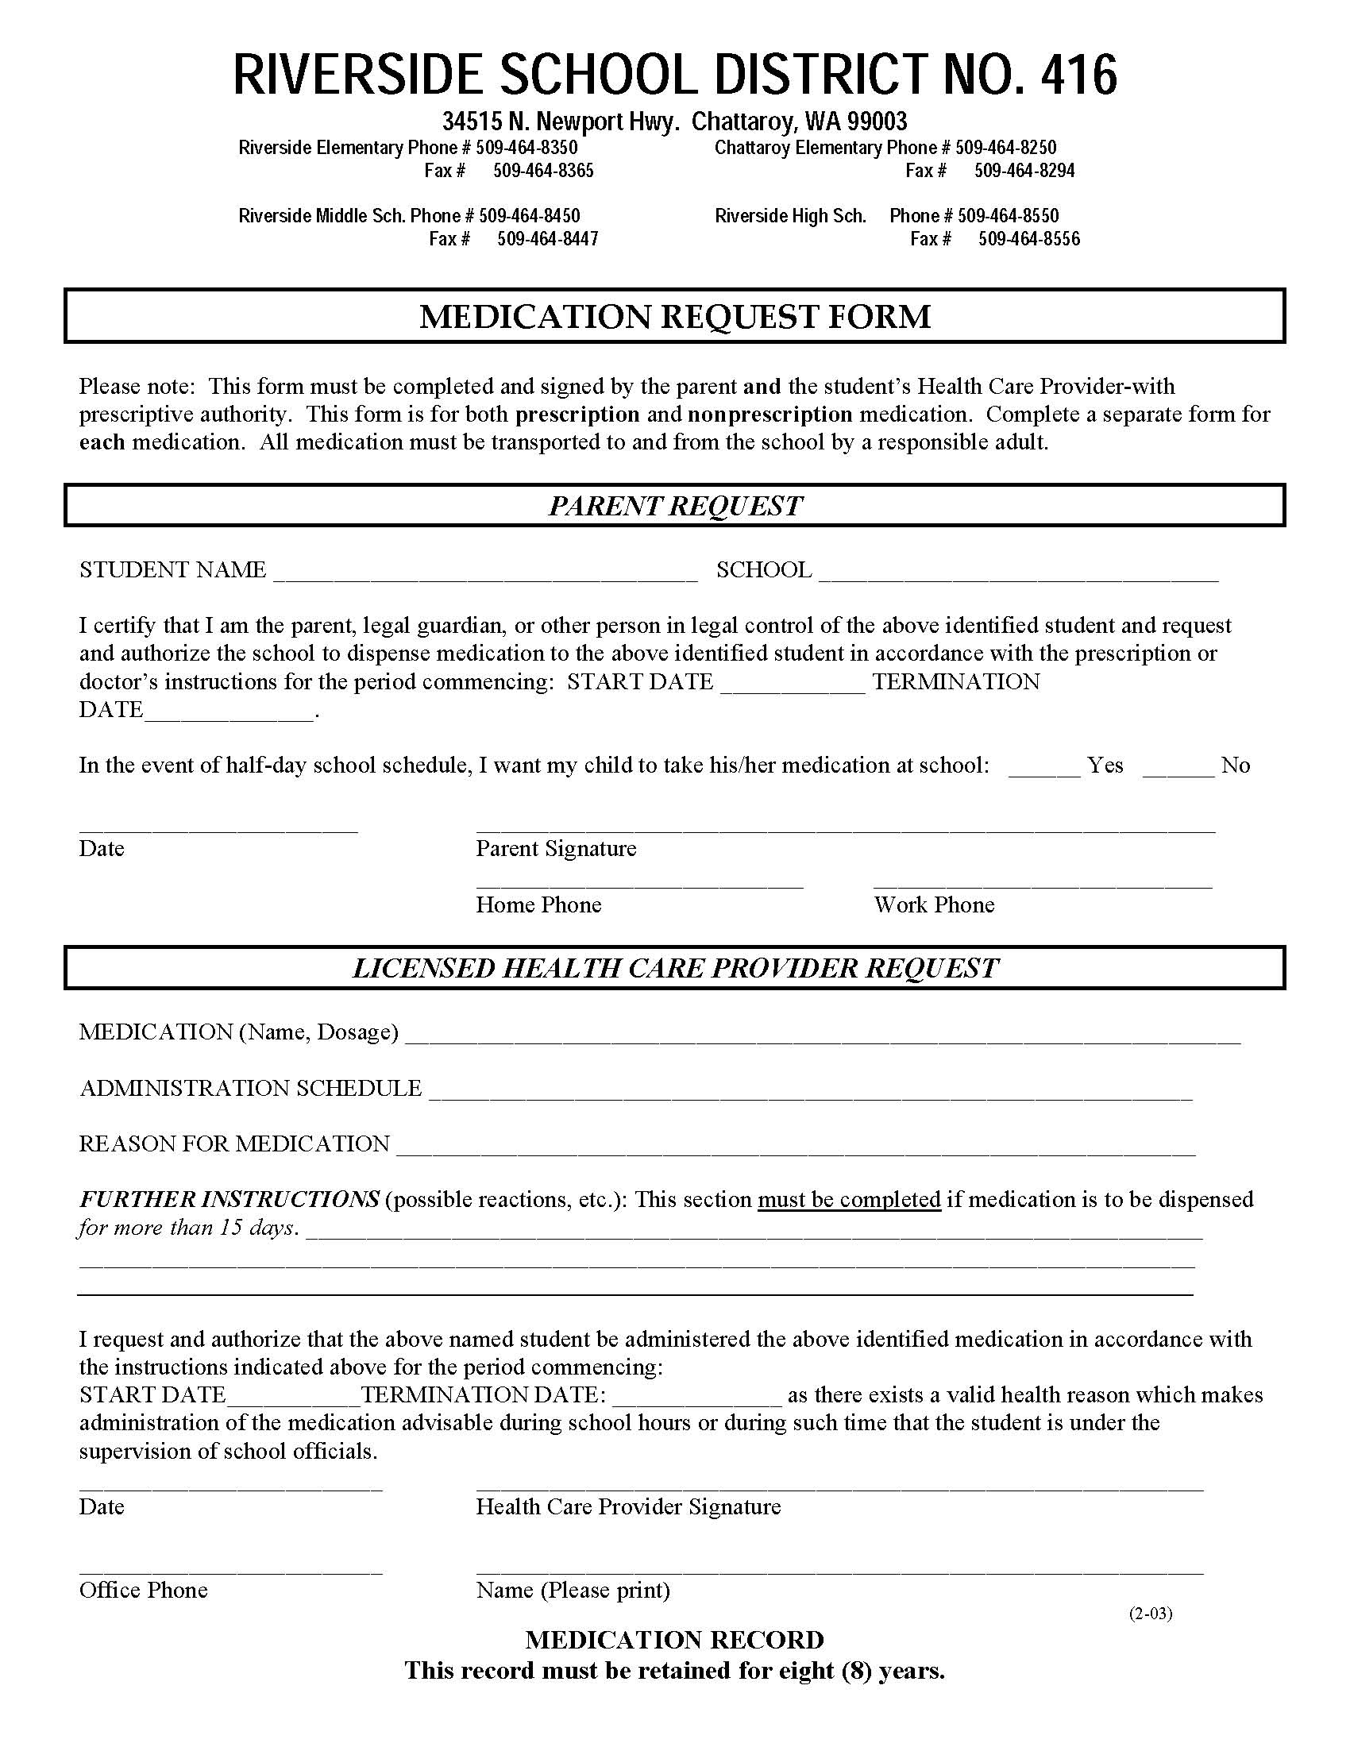
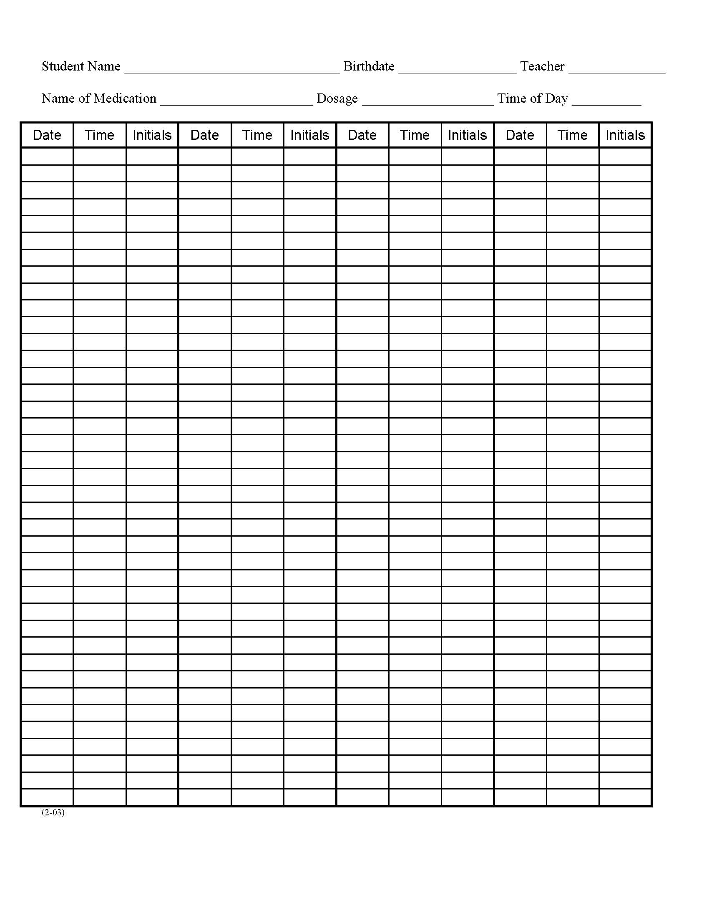
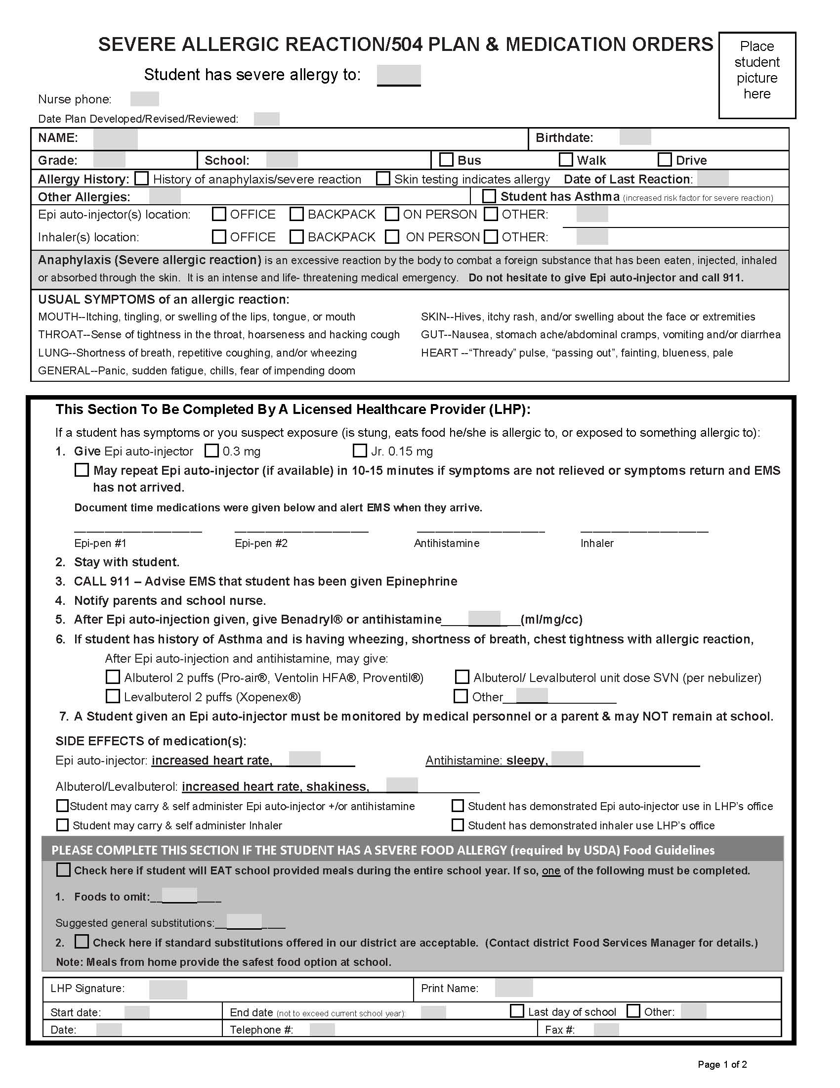
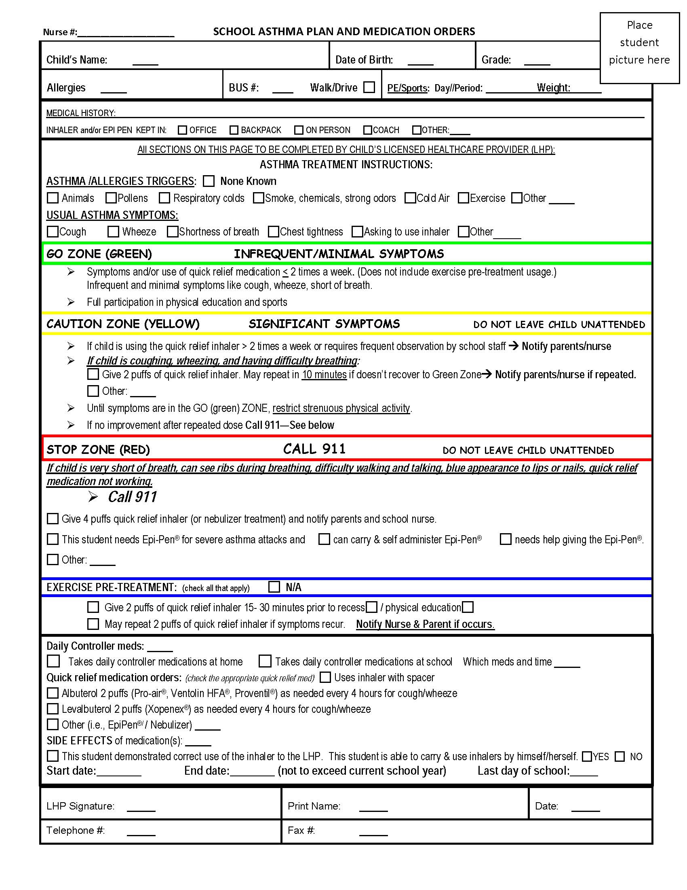

Module III

Emergency Medication Administration



Module III: Emergency Medication Administration

Epinephrine for Anaphylaxis

Anaphylaxis is a life-threatening allergic reaction that can be fatal within minutes. Anaphylaxis can be a reaction to: food (particularly peanuts, tree nuts, fish, wheat or eggs), stinging insects (such as wasps or bees), medications, latex or exercise.

Symptoms of anaphylaxis include:

- Itching and/or hives, particularly in the mouth or throat
- Swelling of the throat, lips, tongue and/or eye area
- Difficulty breathing, swallowing or speaking
- Increased heart rate and/or sense of impending doom
- Abdominal cramps, nausea, vomiting, diarrhea
- Weakness, collapse, paleness, lightheadedness or loss of consciousness

Since the severity of an allergic reaction is difficult to predict, the allergic response may rapidly progress to anaphylaxis. It is important for students with severe allergies who are at risk of anaphylaxis to have an Individualized Healthcare/Emergency Care/504 plan. The IHP/ECP/504 may include the administration of epinephrine from an EpiPen® (RCW 28A.210.370).

Severe allergic reactions may be unavoidable because foods may contain unknown ingredients; insects range widely; and latex can be found anywhere. Once anaphylaxis has begun, the treatment is an immediate injection of epinephrine (EpiPen®) which may be effective for only 10 to 15 minutes. It is not necessary to remove the student’s clothing before administering the EpiPen® auto injector. After receiving the epinephrine, the student should then be transported for further emergency medical attention at the nearest hospital emergency room.

The EpiPen® is a prescribed medication that contains epinephrine to reverse the most dangerous effects of an anaphylactic reaction. The prescription is written according to the weight of the child. The prescribing health care provider will instruct the student/parents/guardians/school nurse, under what circumstances the EpiPen® should be used. Some students may carry and self-administer an EpiPen®. Unlicensed school personnel may administer the EpiPen® after receiving training from a registered nurse. (Guidelines for Care of Students with Anaphylaxis)

The manufacturer recommends the EpiPen® be stored at room temperature in a dark area. The expiration date of the EpiPen® kit should be checked monthly and the parent/guardian notified by school personnel one month in advance of the expiration date.

Module IV

Local School District

Policies and Procedures



Module IV: Local School District Policies and Procedures

Medication Administration

Schools will administer health services per WAC 392-172-A01155(1), (including medication administration) to students who require this service during the school day. Therefore, school districts should have in place, policies and procedures that address how medications and other health services will be delivered. The school district policies and procedures should be readily accessible for reference by all school personnel who may be delegated and trained to administer medication.

Local school district policies for medication administration should include:

- Consent forms to be signed by parent/guardian giving authorization to the school district to administer medication
- HCP forms to be signed regarding medication administration instructions

The above policies would also address prescription medication, OTC medication and self-administered medication.

Other local school district policies/procedures should include:

- Storage of medication
- How to dispose of unused medication
- Administration of medication on a field trip
- Medication administration documentation
- Documentation and reporting of medication errors
- Possession and use of asthma or anaphylaxis medications

The above policies/procedures should also specify the appropriate school district forms to be completed.

3416
Page 1 of 2
ADD IN ___________ SCHOOL DISTRICT POLICY/PROCEDURE

Handouts



Common Medication Abbreviations

Abbreviation | Definition
ac | Before meals
ADD | Attention Deficit Disorder
ADHD | Attention Deficit Hyperactivity Disorder
bid | Two times a day
bucc | Buccal (inside the cheek, along the gum line)
cc | Cubic centimeter (1cc=1mL)
cap | Capsule
D/C | Discontinue
gtt/gtts | Drop/Drops
inh | Inhalation
MDI | Metered-dose inhaler
mg | Milligram
mL | Milliliter (1mL=1cc)
nka | No known allergies
OD | Right eye
OS | Left eye
OTC | Over the counter
OU | Both eyes
Ounce | (1oz=30cc’s=30mL’s)
pc | After meals
PCN | Penicillin
po | By mouth
prn | When needed or necessary
qd | Every day
qh (q1h) | Every hour
qam | Every morning
q2h | Every two hours
q3h | Every three hours
q4h | Every four hours
q6h | Every six hours
qid | Four times a day
qod | Every other day
stat | At once
S/E | Side effects
SL | Sublingual (Under the tongue)
S-R | Sustained release (slow release)
susp | Suspension
tab | Tablet
tid | Three times a day
tsp | Teaspoon (5mL=1tsp)

Glossary of Medical Terms

Term | Definition
Abrasion | Superficial scraping away of the skin
Acute | Sudden onset, the opposite of Chronic
ADD | Attention Deficit Disorder. A disorder manifested by poor impulse control, distractibility and forgetfulness.
ADHD | Attention Deficit Hyperactivity Disorder. ADD with added symptoms of hyperactivity
Adverse effects | Unexpected or unwanted reaction to a medication It may be sudden or develop over time
Allergic reaction | Immune response to a foreign substance resulting in inflammation and/or organ dysfunction. Symptoms may occur immediately or over time, such as redness, rash, hives, itching, swelling, and yellowing of skin and fever
Analgesic | Medicine for relief of pain
Anaphylaxis | Most dangerous type of allergic reaction. Anaphylaxis is a life-threatening event that may include symptoms such as falling blood pressure, respiratory distress and unresponsiveness
Anti anxiety | Medication that reduces the feelings of worry or apprehension
Antibiotic | Medication that kills or stops the growth of bacteria
Anticoagulant | Medication that hinders the coagulation of blood (blood thinner)
Antidepressant | Medication used to relieve or prevent depression
Anti mania | Medication used to relieve the mental state of extreme excitement and activity (manic or bipolar disorders)
Antipsychotic | Medication that reduces the symptoms of psychosis, such as delusions, hallucinations and distorted reality
Antiseptic | Substance that stops or prevents the growth of various microorganisms on the skin
Binging | Period of excessive indulgence as in eating or drinking
Bipolar Disorder | Any of several mood disorders characterized usually by alternating episodes of depression and mania or by episodes of depression alternating with mild nonpsychotic excitement - called also bipolar affective disorder, bipolar illness, manic depression, manic-depressive psychosis
Broad Spectrum Antibiotics | Medication used to treat a wide range of disease causing bacteria
Cerebral stimulants | Medication prescribed for youth with ADD or ADHD often resulting in calmer behavior and better impulse control
“Cheeked” | Medication that has been hidden or attempted to be hidden inside the mouth, generally either in the cheek or under the tongue
Chronic | Persistent or long lasting health condition. Opposite of acute
Conjunctivitis | Itchy swollen eyes that may be caused by allergies, foreign body or bacterial or viral infection. Highly contagious. (also called “pinkeye”)
Controlled substances | Potentially addictive medications regulated by Federal laws
Corticosteroids | (Also called "steroids") are medications prescribed to quickly reduce inflammation and pain. To maximize benefits, but minimize potential side effects, corticosteroids are usually prescribed in low doses or for short durations
Decongestant | Broad class of medications used to relieve nasal congestion. Generally, they work by reducing swelling of the mucous membranes in the nasal passages
Dermal | Refers to skin
Dermatitis | Inflammation of the skin; the skin inflammation varies from mild irritation and redness to open sores, depending on the type of irritant, the body part affected, and sensitivity
Dyspnea | Difficulty in breathing
Dyspepsia | Indigestion, heartburn
Edema | Swelling
Enteric coating | Substance covering a tablet that will not dissolve until reaching the small intestine
EpiPen® | Disposable pre-filled injectable medication prescribed for treating severe allergic reactions causing respiratory distress (anaphylaxis)
Epilepsy | Neurological disorder that causes recurrent seizures
Expectorant | Medication that loosens mucous from the respiratory tract
Feces | Also called stool
Finger cot | Close fitting sheath worn at the end of a finger as a device for protection of the finger
Flat affect | Lack of emotional response; no expression of feelings; talking in monotone voice or having lack of facial expression
Fungicidal | Medication used to kill fungus
Grandiosity | False or exaggerated belief in one’s own worth
Grand Mal Seizure | Major epileptic seizure involving the entire body
Hallucinations | Perceived sights, sounds, tastes, smells, or sensations that are not actually there
Hypertension | High blood pressure readings above the “normal” range appropriate for age
Hypoglycemia | Abnormally low blood sugar
Hypothyroidism | Condition of the thyroid gland characterized by low energy, weight gain and often can mimic depression
Inflammation | Response of the immune system to injury or destruction of cells. Symptoms may include redness, heat, pain and swelling
Jaundice | (Icterus) Yellowing of the whites of the eyes, skin and body fluids
Lacerations | Cuts or scratches on the body
Laxatives | Medications that will cause evacuation of feces (stool) from the body
Lethargic | Drowsy or sluggish, difficult to stay awake
Licensed Practitioner | Individual who has been granted a license to practice within the parameters designated by the board of record. The NCQAC grants licenses to RNs, APRNs and LPNs.
Mania | Mental state of extreme excitement and activity (Manic)
MAR | Medication Administration Record; documentation record for medications given
Narcolepsy | Chronic sleep disorder in which a person experiences extreme tiredness and possibly falls asleep during inappropriate times, such as at work or school
Nebulizer | Device used to administer medication in the form of a liquid mist into the airways
Non-controlled medications | Non-controlled medications – Medications with no history of addictive potential; not governed by the same laws and storage requirements as for controlled medications
Ophthalmic | Pertaining to the eyes
Oral medications | Drugs that are given by mouth
Otic | Pertaining to or concerning the ear
Over-the- Counter (OTC) medications | Medications that may be purchased without a prescription, such as Tylenol® or Advil®
Paranoid Disorder | Excessive anxiety or fear concerning one’s own well being
PRN medications | Medications ordered to be given only on an “as needed” basis, such as Tylenol for a headache
Psoriasis | Chronic skin disease with scaly red patches
Psychotherapeutic agents | Classification of medication used to treat mental disorders, may be prescribed to treat depression, psychosis or bipolar disorders
Route of administration | How a medication is to be given, such as by mouth, on the  skin (topical), etc
Seizure | Brief, excessive discharge of electrical activity in the brain that alters one or more of the following: movement, sensation, behavior, awareness
Tardive Dyskinesia (TD) | Neurological disorder that may be due to long term and/or high does use of some antipsychotic medications; characterized by abnormal repetitive, involuntary movement of the face, such as grimacing, lip smacking, or rapid eye blinking
Topical medication | Medications applied to the skin
Tourette Syndrome | Neurological disorder characterized by unusual, involuntary movements or sounds, called tics. Common tics are throat-clearing and blinking. May occur with other neurological disorders such as ADHD, Obsessive-Compulsive Disorder (OCD), anxiety or depression

Steps for Proper Hand Washing

Proper hand washing is essential in preventing the spread of germs.

Always wash your hands before preparing to administer medications.

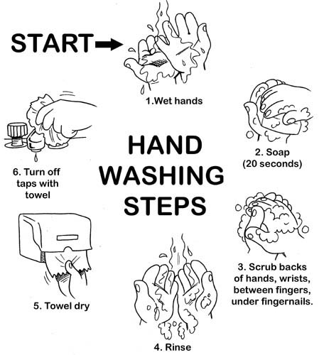

Alcohol-Based Hand Sanitizers

Alcohol-based hand sanitizers are an alternative when soap and water are not available. However, if hands are visibly soiled, soap and water must be used.

Using an alcohol-based hand sanitizer

- Apply ½ tsp (nickel size) of the sanitizer to the palm of the hand
- Rub hands together, covering all surfaces until they are dry (approximately 20 seconds)


Six Rights of Medication Administration

- Right Student
Always have two (2) ways of identifying the student when administering medications.

- Right Medication
Verify that the name of the medication on the label on the medication container matches the information on the Medication Administration Log

- Right Dose
Read the label on the medication container and compare it to the information on the Medication Log. Be sure to note the dose of the medication to be given.

- Right Route
Read the label on the medication container and compare it to the information on the Medication Log. Be sure this information matches.

- Right Time
Follow the instructions on the Medication Log. Compare with the instructions on the medication container label. Follow school district policy for the time frame acceptable to give the medication. (Example: 30 minutes before or 30 minutes after the scheduled time.)

- Right Documentation
Each medication given must be documented when it is given. (Remember - If a medication has been given but not documented, there is the potential of overdosing.)

Always Check the Medication:

- When removing the medication from storage (drawer/shelf)
- When removing the medication from the container/package
- When returning the medication container to storage (drawer/shelf)



Brand and Generic Names for Common Medications

Brand Name | Generic Name | Brand Name | Generic Name
Abilify | Aripiprazole | Metadate ER, Metadate CD | Methamphenidate
Actifed | Aphedrid, Aprodine | Mellaril | Thioridazine
Adderall,  Adderall XR | Amphetamine Sulfate | Motrin | Ibuprofen
Advil | Ibuprofen | Neurontin | Gabapentin
Atarax | Hydroxyzine | Paxil | Paroxetine
Ativan | Lorazepam | Prozac | Fluoxetine
Benadryl | Diphenhydramine HCL | Remeron | Mirtazapine
Buspar | Buspirone | Risperdal | Risperidone
Catapres | Clonidine | Ritalin, Ritalin SR,  Ritalin EC | Methamphenidate
Celexa | Citalopram | Robitussin DM | Guaifenesin Dextromethorphan Hbr
Claritin | Loratidine | Seroquel | Quetipine
Cogentin | Benztropine | Singulair | Montelukast
Colace | Docusate Sodium | Strattera | Atomoxetine
Concerta | Methamphenidate | Synthroid | Levothyroxine
DDAVP | Desmopressin acetate | Tegretol, Carbitrol | Carbamazepine
Depakote | Divalproex Sodium` | Tenex | Guanfacine
Desyrel | Trazodone
Dexadrine | Dextroamphetamne Sulfate | Thorazine | Chlorpromazine
Effexor | Venlafaxine | Tinactin | Tolnaftate
Eskalith | Lithium | Topamax | Topiramate
Gabitril | Tiagabine
Gas-X | Simethicone | Trileptal | Oxcarbasepine
Geodon | Zipraxidone | Tylenol | Acetameniphen
Haldol | Haloperidol | Valium | Diazepam
Imipramine Hcl | Imipramine | Wellbutrin, Wellbutrin SR | Bupropion
Immodium | Loperamide | Xanax | Alprazolam
Lamictal | Lamotrigine | Zantac | Ranitidine
Lexapro | Escitlopram | Zoloft | Sertraline
Lithobid | Lithium | Zyprexa | Olanzapine
Lotrimin | Clotrimazole
Luvox | Fluvoxamine

Common Medications

Please note: Not an all inclusive list

Medication Classification | Common Use | Common Names | Common Adverse/  Side Effects
Antibiotics  *Pay close attention to any student allergies | Infections caused by bacteria. Not commonly used for viruses. | Amoxicillin, Ampicillin, Penicillin, Cefaclor (Ceclor), Ceftin, Biaxin, Zithromax | Nausea, diarrhea, rash, yeast infections, fever
Anti-Asthma agents | Asthma, respiratory distress | Advair, Albuterol, Singulair | Nervous feeling, sweating, nausea, vomiting
Antihistamines | Allergies (i.e. hay fever) | Tavist-D, Claritin, Singulair, Zyrtec, Allegra, Benadryl | Drowsiness, insomnia, weakness
Analgesics | Pain relief | Tylenol, Advil, Aspirin | Stomach upset,  tinnitus, nausea
Anticonvulsants  Antiepileptic | Neurological disorders, seizures | Phenobarbital, Valproic Acid, Tegretol,  Dilantin, Topamax | Dizziness, drowsiness, confusion, fainting
Antidiabetics | To treat diabetes | Insulins, Actos, Glucophage, Glucotrol | Nausea, heartburn, fatigue, dizziness
Cardiovascular | High blood pressure, irregular heart-beat, heart failure | Tenormin, Capoten, Catopres | Dizziness, drowsiness, chest pain, loss of appetite, leg pain
Cerebral stimulants | Attention Deficit Disorder (ADD/ADHD), Narcolepsy | “CONTROLLED”  Adderall, Ritalin | Insomnia, irritability, restless, decreased growth
Decongestants | Relieves congestion | Tavist-D, Clartin-D | Nose bleed, nasal irritation
Dermatological (skin) | Skin infections | Bacitracin, Zovirax, Neosporin | Rash, skin irritation, burning
Gastrointestinal:  Antacid  Anti-Ulcer  Anti-Diarrhea  Laxatives | Heartburn, acid reflux  Treat ulcer condition  Stop diarrhea  Relieve constipation | Tums, Mylanta, Maalox  Tagamet, Pepcid,Zantac  Immodium, Lomotil  Metamucil, Colace, Surfak | Constipation, bloating  Dizziness, mild diarrhea  Fatigue, dry mouth, nausea  Cramping, depends on medication for bowel movement
Opthalmic (eye) | Eye irritation or infection | Polysporin,  Neosporin, Liquifilm | Burning sensation,  Itching, blurred vision
Otic (ear) | External ear infections | Acetic Acid (VoSol), Ofloxacin | Ear irritation, itching
Psychotherapeutic agents:  Antidepressants  Antipsychotic  Anti-mania | Depression  Psychosis, behavior disorder  Bipolar disorder | Wellbutrin, Paxil, Zoloft  Abilify, Risperdal, Haldol  Lithium, Eskalith | Weight gain, insomnia, nervous feeling  Tardive dyskensia, sedation  Tremors, drowsiness, thirst

Medication Administration Incident Report Form

Student name: _____________________________________________________________ Date of birth: ____________________

School name: ___________________________________________________________________________ Grade: __________

Date/time of error: _________________________________________________________________________________________

Name of person administering medication: ______________________________________________________________________

Name of medication: ______________________________ Dosage:_____________ Route: _______________________________

Time(s) to be given: ________________________________________________________________________________________

Circle all that apply to this medication error:

Wrong student Wrong time Wrong dose

Wrong route Wrong medication Wrong documentation

Describe the error (should be completed by the person making the error. If wrong medication given, include the name and dosage of what was given):

________________________________________________________________________________________________________

________________________________________________________________________________________________________

_________________________________________________________________________________________________________

Action taken/intervention: ___________________________________________________________________________________

_________________________________________________________________________________________________________

Persons notified at time of error: _______________________________________________________________________________

Principal (signature required): _________________________________________Date/time of notification_____________________

Supervising school nurse: _________________________________________Date/time of notification_____________________

Parent or guardian notified: _________________________________________Date/time of notification_____________________
(if applicable)

Student’s Health Care Provider notified: ________________________________________________________________________

Date/time of notification: ____________________________________________________________________________________
(if applicable)

Name of person completing incident report: _____________________________________________________________________
(please print)

Signature (person completing incident report: ____________________________________________________________________

Date: ________________________________

Follow-up care/information (if applicable) :_______________________________________________________________________

_________________________________________________________________________________________________________

The Family Educational Rights and Privacy Act (FERPA)
20 U.S.C. § 1232g; 34 CFR Part 99

The Family Educational Rights and Privacy Act (FERPA) (20 U.S.C. § 1232g; 34 CFR Part 99) is a Federal law that protects the privacy of student education records. The law applies to all schools that receive funds under an applicable program of the U.S. Department of Education
Generally, schools must have written permission from the parent or eligible student in order to release any information from a student's education record. However, FERPA allows schools to disclose those records, without consent, to the following parties or under the following conditions (34 CFR § 99.31):
- School officials with legitimate educational interest;
- Other schools to which a student is transferring;
- Specified officials for audit or evaluation purposes;
- Appropriate parties in connection with financial aid to a student;
- Organizations conducting certain studies for or on behalf of the school;
- Accrediting organizations;
- To comply with a judicial order or lawfully issued subpoena;
- Appropriate officials in cases of health and safety emergencies; and
- State and local authorities, within a juvenile justice system, pursuant to specific state law.

Forum Guide to the Privacy of Student Information: A Resource for Schools
(NFES 2006–805). U.S. Department of Education, Washington, DC: National Center
for Education Statistics

Appendix

Statutory/Regulatory Reference | Title/Description | Link
RCW 28A.210.260 | School health services – Expanding types of medications school employees may administer | apps.leg.wa.gov/rcw
RCW 28A.210.270 | Health services in the school setting – Designated provider– Liability protection | apps.leg.wa.gov/rcw
RCW 28A.210.260 | Staff Model for Delivery of School Health Services | www.k12.wa.us/HealthServices/pubdocs/SchHealth.pdf
Policy 3416  Procedure 3416P | Riverside School District policy/procedures | www.riversidesd.org
RCW 28A.210.370 | Self-administration of medications by students with asthma or anaphylaxis – authorization – written statement – acknowledgement of liability limitation – duration of permission | apps.leg.wa.gov/rcw  www.k12.wa.us/HealthServices/pubdocs/GuidelinesforCareofStudentswithAnaphylaxis2009.pdf
RCW 28A.210.370 | Possession and use of asthma or anaphylaxis medications.  Guidelines for Care of Students with Anaphylaxsis | apps.leg.wa.gov/rcw  www.k12.wa.us/HealthServices/pubdocs/GuidelinesforCareofStudentswithAnaphylaxis2009.pdf
RCW 18.71 | Physicians – prescriptive authority | apps.leg.wa.gov/rcw
RCW 18.130 | Law relating to nursing care and regulation of health professions – Uniform Disciplinary Act, WSDOH | apps.leg.wa.gov/rcw
RCW 18.79.240 (1)(b)  RCW 18.79.260 (2) | Delegation of nursing tasks requiring the use of emergency medications | apps.leg.wa.gov/rcw
WAC 246-840-700 | Roles of nurses in the supervision and delegation of nursing acts to unlicensed personnel | apps.leg.wa.gov/WAC
WAC 246-840-705 | Functions of registered nurse, licensed practical nurse | apps,leg.wa.gov/WAC
RCW 28A.210.320 | Children with life-threatening health conditions | apps.leg.wa.gov/rcw
20 U.S.C. § 1232g; 34 CFR Part 99 | The Family Educational Rights and Privacy Act (FERPA) | http://regweb.unc.edu/official/FERPA/FERPA.html
RCW 18.79 | Law relating to ARNPs prescribing medications | apps.leg.wa.gov/rcw
WAC 246-840 | Scope of practice for ARNP, RN, and LPN | apps.leg.wa.gov/rcw
WAC 246-840-300 | Scope of practice for ARNPs | apps.leg.wa.gov/rcw
NASN | National Association of School Nurses – The Role of the School Nurse (1999) | www.nasn.org
WAC 246-840-010 (10) | Delegation of nursing tasks to nonlicensed personnel | apps.leg.wa.gov/wac
RCW 18.79 | Law relating to RN and LPN practice | apps.leg.wa.gov/rcw
RCW 70.02.030 thru  70.02.050 | Laws relating to confidentiality | apps.leg.wa.gov/rcw
WAC 392-172-A01155(1) | Rules related to provision of school health services and school nurse services | apps.leg.wa.gov/wac

Competency #1

Oral Medication Administration

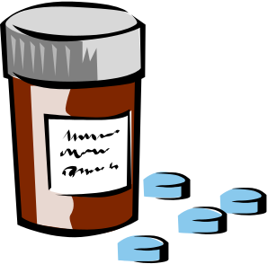
- Follow the Six Rights of Medication Administration; Right student, Right medication, Right dose, Right time, Right route and Right documentation.
- Wash hands.

- Pour medication into the bottle lid and then into the disposable medicine cup.

- Provide the student with water or other liquid that allows for easy swallowing.

- Verify the student has swallowed the medication.

- Document on the medication administration record (medication log) that you have administered the medication.

- Replace the medication in locked storage area.

- Observe the student for any medication reaction as appropriate.

_________________________________________ __________________
Staff signature Date

_________________________________________ __________________
Registered nurse signature Date

Competency #2

Liquid Medication Administration

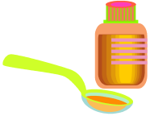

- Follow the Six Rights of Medication Administration; Right student, Right medication, Right dose, Right time, Right route and Right documentation.
- Wash hands.
- Have the container at eye level when measuring.

- Holding the bottle so that the label is in the palm of the hand, pour the liquid into a plastic marked cup. Pay attention to the markings on the container to make sure the dose is accurate.

- Verify the student has swallowed the medication.

- Document on the medication administration record (medication log) that you have administered the medication.

- Replace the medication in locked storage area.

- Observe the student for any medication reaction as appropriate.

_________________________________________ __________________
Staff signature Date

________________________________________ __________________
Registered nurse signature Date
Competency #3

Eye Drops or Ointment

- Follow the Six Rights of Medication Administration; Right student, Right medication, Right dose, Right time, Right route and Right documentation. (Know which eye is to be treated. Initials may be used to specify the eye that requires treatment, O.D. = right eye; O.S. = left eye; O.U. = both eyes).
- Wash hands.
- Put on gloves.
- Stabilize the head by having the student tilt their head back or have them lie down.
- Have the student look upward.
- Gently pull the lower lid away from the eye to form a “pocket”.
- Place drop(s) into pocket area allowing the drop to fall into the pocket. Do not place medicine directly on the eye itself. Make sure the bottle tip does not touch the eye or eyelid. 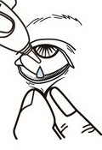
- If an ointment is used, apply a thin strip into the “pocket” without touching the eye or eyelid.
- Have the student close their eye(s) for a few moments.
- Dab away excess with tissue.
- Remove gloves.
- Document on the medication administration record (medication log) that you administered the medication.
- Replace medication in locked storage area.
- Observe the student for any medication reaction as appropriate.
______________________________________ __________________ Staff signature Date
_______________________________________ ___________________ Registered nurse signature Date

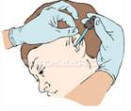
Competency #4
Ear Drops

- Follow the Six Rights of Medication Administration: Right student, Right medication, Right dose, Right time, Right route and Right documentation.
- Wash hands.
- Put on gloves.
- Loosen lid on medication and squeeze rubber stopper to fill the dropper.
- Stabilize the student’s head by tilting it toward the opposite shoulder and turn head to the side or have them lie down on their side.

- Gently pull the top of the ear (cartilage) back and up and hold.

- Place the prescribed number of drops into the ear canal without touching the dropper to the ear.

- Have the student remain in the same position for a few minutes to avoid leakage.

- Remove gloves.

- Document on the medication administration record (medication log) that you administered the medication.

- Replace medication in locked storage area.

- Observe the student for any medication reaction as appropriate.

_______________________________________ ____________________
Staff signature Date

_______________________________________ ____________________
Registered nurse signature Date

Competency #5

Topical Ointment or Creams

- Follow the Six Rights of Medication Administration; Right student, Right medication, Right dose, Right time, Right route and Right documentation.

- Wash hands.

- Put on gloves.

- Loosen cap on the medication and squeeze a small amount directly onto cotton tipped applicator (Q-tip®).

- Apply ointment directly to the area or give applicator to student for them to apply.

- Cover Area, if indicated.

- Remove gloves.

- Document on the medication administration record (medication log) that you administered the medication.

- Replace medication in locked storage area.

- Observe the student for any medication reaction as appropriate.

_________________________________________ __________________
Staff signature Date

________________________________________ __________________
Registered nurse signature Date

Competency #6

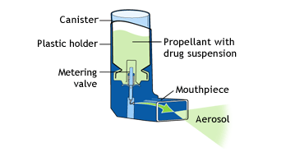
Metered Dose Inhalers (MDI)

HFA (hydrofluoroalkane) Inhalers

A metered dose inhaler is a pressurized canister of medicine that is sprayed through a mouthpiece. You can help a student follow these simple steps to properly use their MDI.

- Follow the Six Rights of Medication Administration; Right student, Right medication, Right dose, Right time, Right route and Right documentation.

- Wash hands.

- Shake the inhaler several times. Prime inhaler if necessary.
- Check that canister is firmly positioned in plastic holder (and attach spacer if required.)
- Have student slightly tilt their head backward.
- Have student breathe out (exhale) completely.
- Have student place the mouthpiece between the teeth and close lips around it.
- Squeeze the inhaler to discharge the medicine and have student begin to inhale immediately.
- Instruct student to breathe in slowly and deeply for 3-5 seconds. Once inhaled, have student remove the inhaler from their mouth, hold their breath for 5-10 seconds and then exhale.
- Rest for a minute, then repeat this sequence for each prescribed “puff”.
- Document on the medication administration record (medication log) that you administered the medication.
- Replace medication in locked storage area.
- Observe the student for any medication reaction as appropriate.

__________________________________________ _______________________
Staff signature Date

__________________________________________ ______________________
Registered nurse signature Date

Competency #7

How to Administer an EpiPen®
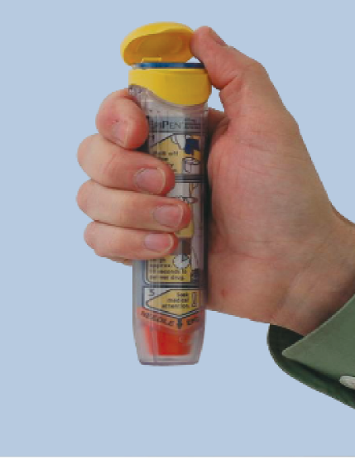
- Identify someone to call 9-1-1.

- Flip open cap at top of carrier tube.

- Remove EpiPen® from carrier tube and
remove the blue safety release. 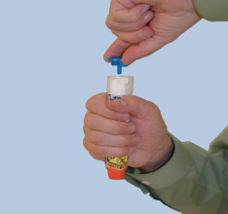

- Form a fist around the unit with the orange tip pointing downward.
- Swing and firmly push orange tip against outer thigh until click is heard.
(Auto-injector may be given through clothing). 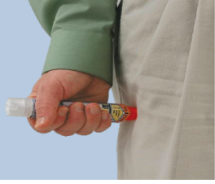
- Hold in place for 10 seconds. The injection is now complete.
- Remove pen from thigh and massage injection site for 10 seconds.
- Place used auto-injector into carrier tube and give to EMS when they arrive.
- Document administration of EpiPen® in Medication Administration Record (MAR).

Note: Always refer to the package insert for additional information on administration.

_______________________________________________ ____________________________
Staff signature Date

_______________________________________________ ____________________________
Registered nurse signature Date

Medication Administration
Written Competency Test
For
Non-Licensed
School Personnel

Module I: Legal Issues, Policies and Procedures

    - Unlicensed school personnel may be delegated to administer medications in schools by their:
_______________ _____________.

    - The length of time that the delegation and training is valid for unlicensed school personnel is the ________________ ______________ ______________.

    - Periodic supervision of a nursing task must be provided by the _____________ ____________.

    - True or False: Supervision of unlicensed school personnel requires that the supervising nurse be physically present in the same school building.
    - Information regarding student health information may only be shared with school personnel on a ____________ ______ ____________ basis.
    - True or False: All unlicensed school personnel administering medications should be familiar with their district’s policies and procedures for medication administration.
    - The completed medication authorization form signed by the parent/guardian and HCP is valid only for the ____________ school year.

    - All medication should be sent to school in the ___________ labeled container.
    - True or False: Except for emergency medications, all medications should be kept in an appropriately labeled, secure, locked cabinet accessible only by responsible, authorized school personnel.

    - True or False: For field trips, student medication may be repackaged by placing the necessary medication needed into a smaller container and labeled with the student’s name, medication name, and time medication is to be given.

    - Examples of medication errors include:

A._______________________________ B._______________________________

C._______________________________ D. _______________________________
E. _______________________________ F. _______________________________

    - Errors made in recording medication on the Medication Administration Record should be marked as _________________, _________________ and ______________________.

    - If a medication error occurs, ____________________ notify the delegating school nurse and Principal and complete a Medication Administration Incident Report form.

Module II: Classification of Medications, Medication Preparation, Administration, and Documentation

- ___________________medications are those medications that a licensed practitioner orders to treat a particular medical diagnosis or symptoms.
- An unwanted, unexpected or potentially dangerous response to a medication is known as ________________________________.
- True or False: A licensed practitioner must write an order (or prescribe) oral medication to be crushed.
- Suspensions are a form of liquid medication that must be ________________________ before being measured and administered.

- When pouring liquid medication the label should face the ______________ of the hand to prevent spilling on the label and causing the label to be illegible.
- All oral medications should be given with ____________or other ____________ to allow for easy swallowing.
- It is important to verify that the student has swallowed the medication by asking them to open their mouth and checking under the tongue, roof of mouth, and _____________ for hidden medication.
8. True or False: When administering eye (ophthalmic) drops, gently pull down the lower
eyelid to create a pouch or “pocket.”

9. True or False: When administering ear drops, gently pull the top of the ear (cartilage)
back and up and hold.

10. List the “Six Rights” of medication administration:

1_______________________________ 4. ________________________________
2_______________________________ 5. ________________________________
3._______________________________ 6. ________________________________

11. True or False: To ensure the right medication is given to the right student, always compare the medication label on the prescription bottle with the student’s Medication Administration Record.

12. If the medication has been administered but not documented on the Medication Administration Record, there is the potential for _________________________ if the medication were to be re-administered.

13. True or False: The Medication Administration Record is a legal and permanent document and therefore, only ink and never “whiteout” must be used.

Module III: Emergency Medication Administration

      - True or False: Anaphylaxis is a life-threatening allergic reaction that can be fatal within minutes.

      - True or False: Anaphylaxis can be a reaction to: foods, stinging insects, medication, latex or exercise.

      - List symptoms of anaphylaxis:

A. _____________________________
B. _____________________________
C. _____________________________
D. _____________________________
E. _____________________________

4. The ____________________ is a prescribed medication that contains epinephrine to reverse the most dangerous effects of an anaphylactic reaction.

5. Once administered, epinephrine may only be effective for __________________ to _________________ minutes.

6. True or False: Washington state law permits a student to self-carry and self-administer medication to treat anaphylaxis.

- True or False: The emergency medications, EpiPen’s® and inhalers must be checked for their expiration date and parents notified in advance of the expiration date.

Module IV: Local School District Policies and Procedures

Discussion Questions

- Describe your school district’s policy and procedure for daily medication administration.

- Describe your school district’s policy for administering over-the-counter (OTC) medication such as Tylenol.

- Describe your school district’s policy and procedure for administering medications to students on a field trip during the school day.

- How does the school district policy state all student medication is to be stored?

- Describe your district’s policy for disposing of unused medication.

- Describe your district’s policy and procedure for reporting and documenting medication errors.

- Review your district Medication Administration Record and how to document medications administered or refused.

_______________________________________ _________________________
Staff member signature Date

_______________________________________ _________________________
Registered nurse signature Date

