

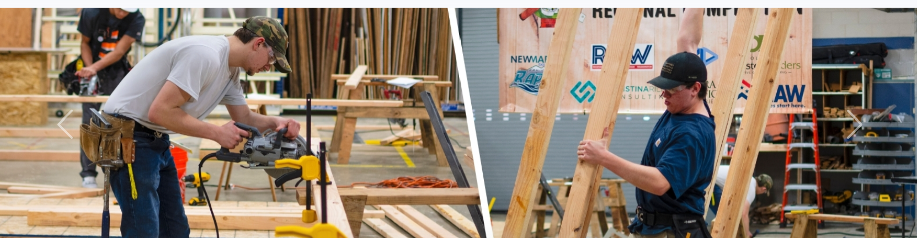
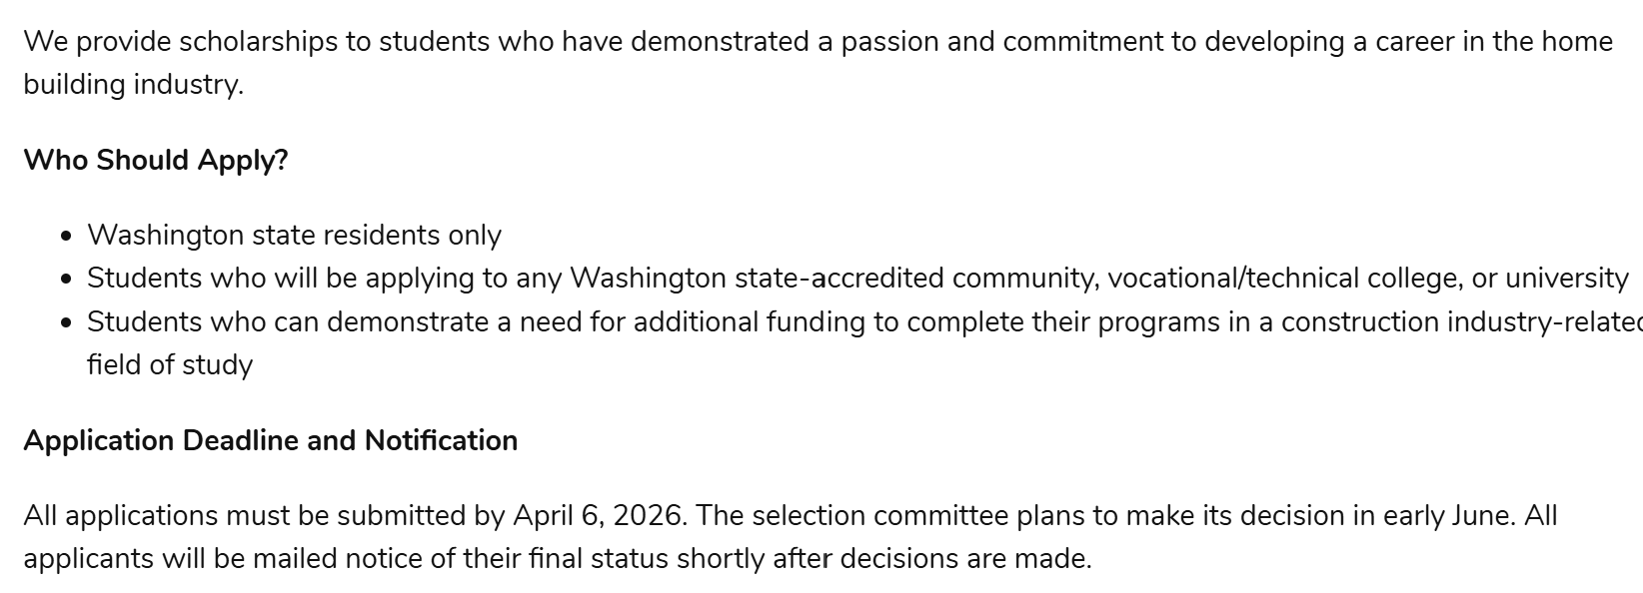

For more information and application go to Welcome | Building Industry Association of Washington

