**Student Name:**

**2027**

**GRADE 11**

**LYNDEN HIGH SCHOOL**

2025 - 2026SCHEDULING WORKSHEET

**PLEASE READ**: It is important that you

\***RQ** = Required Course / RC = Recommended Course

think carefully about your course selections.

**After the master schedule is built and**

|  |  |  |
| --- | --- | --- |
| **SAMPLE SCHEDULE** | | |
| **RQ** | English – see options below | Year-Long |
| **RQ** | US History-see options below | Year-Long |
| **RQ** | Math – see options below | Year-Long |
| **RQ** | Chemistry – see options below | Year-Long |
| RC | Elective | 2 Semesters |
| RC | Elective | 2 Semesters |

**schedules are created, there are no**

**schedule changes**

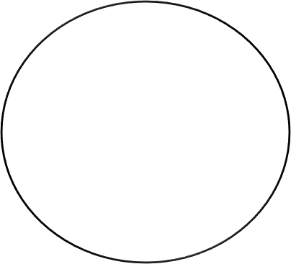

**IMPORTANT DATE**

Friday, April 18 **Complete Course Request Entry into Skyward**

**Junior Requirements – 6.0 Total Credits**

|  |  |  |
| --- | --- | --- |
| COURSES | SEMESTER 1 | SEMESTER 2 |
| JUNIOR ENGLISH   * 1.0 CREDIT | * American Literature A * Creative Writing A * AP English Language A | * American Literature B * Creative Writing B * AP English Language B |
| JUNIOR SOCIAL STUDIES   * 1.0 CREDIT | * US History A * CIHS US History A | * US History B * CIHS US History B |
| JUNIOR SCIENCE   * 1.0 CREDIT | * Conceptual Chemistry A * Chemistry A (pre-req Alg 2) | * Conceptual Chemistry B * Chemistry B (pre-req Alg 2) |
| MATH   * 1.0 CREDIT   4TH Year of Math is recommended. Choose the next Math in your sequence.  University requires a senior math unless  Pre-Cal in Junior Year. | * Geometry A * Algebra 2 A * Honors Algebra A * CIHS Pre-Calculus A * CIHS/AP Statistics A | * Geometry B * Algebra 2 B * Honors Algebra 2 B * CIHS Pre-Calculus B * CIHS/AP Statistics B |
| ELECTIVE  Science, World Lang., Arts, Music, CTE, PE |  |  |
| ELECTIVE  Science, World Lang., Arts, Music, CTE, PE |  |  |

**REQUIRED: SELECT 3 ALTERNATES** REMEMBER to add your alternates in Skyward.

|  |  |  |  |  |  |
| --- | --- | --- | --- | --- | --- |
| 1. |  | 2. |  | 3. |  |