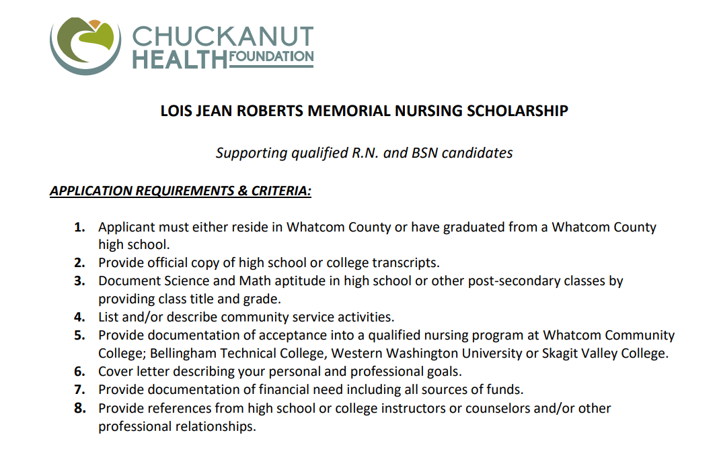

For application and more information go to:
Nursing Scholarships — Chuckanut Health Foundation
Deadline May 20, 2024

