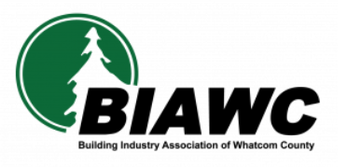
The Building Industry Association of Whatcom County is pleased to support learning beyond high school. To qualify for a scholarship, applicants must be pursuing post-secondary (after high school) training or education, involving any subject. They must either own or work for or be a family member of anyone who owns or works for, a BIAWC member company. Scholarships go toward tuition, fees, and books for the upcoming academic year, only at the school or program(s) described below. If you’re applying for acceptance at more than one school or program, please list all of them and explain below. Scholarship monies are distributed directly to the school, not the applicant.
Applicants must complete this form and provide a personal statement describing information on your work and extra-curricular activities as described, 3 current signed letters of recommendation, a current transcript, and a letter of acceptance from your intended school if you are entering a new program. Applicants can fill out the online form by going to https://members.biawc.com/scholarships and mail all required personal statements to:
BIAWC Scholarship Program
1650 Baker Creek Place
Bellingham, WA 98226
Completed applications may also be delivered in person or sent electronically to grettam@biawc.com; please use the term “Scholarship” in the subject line of all emails.

APPLICATION DEADLINE
All applications and supporting materials must be received by noon, Friday, April 26, 2024, to be considered.

